SMS CENTER
LOGIC MANUAL

Created By Kresnoadi
Created On 20/08/2009

Login

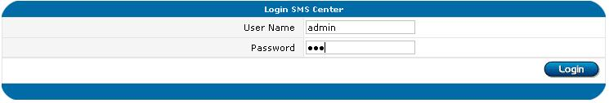

User Registration Input

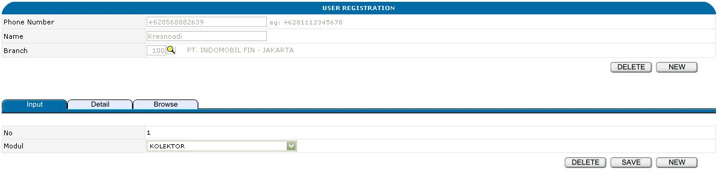

Buttons
Top
New
Delete

Bottom
New
Save
Delete

Tabulation
Detail
Browse

User Registration Detail

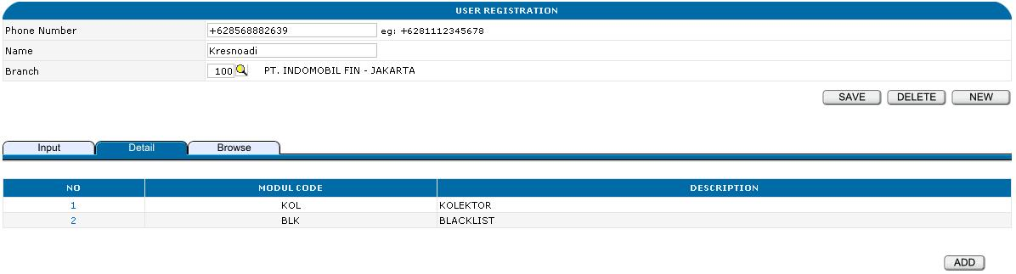

Hyperlink
No

Buttons
Top
New
Save
Delete

Bottom
Add

Tabulation
Input
Browse

User Registration Browse

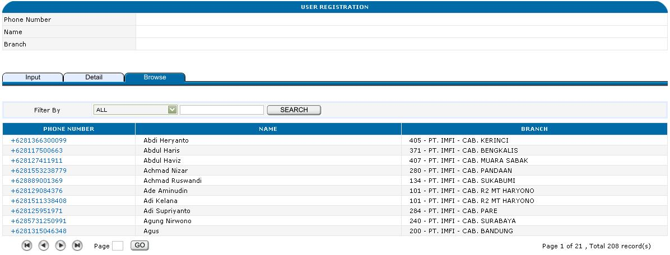

Hyperlink
Phone Number

Tabulation
Input
Detail

Module Browse

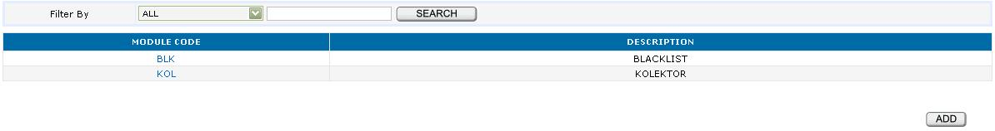

Hyperlink
Module Code

Button
Add

Module Input

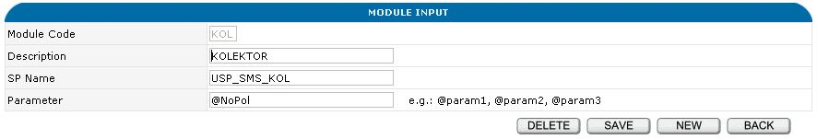

Buttons
New
Save
Delete
Back

Inbox Browse

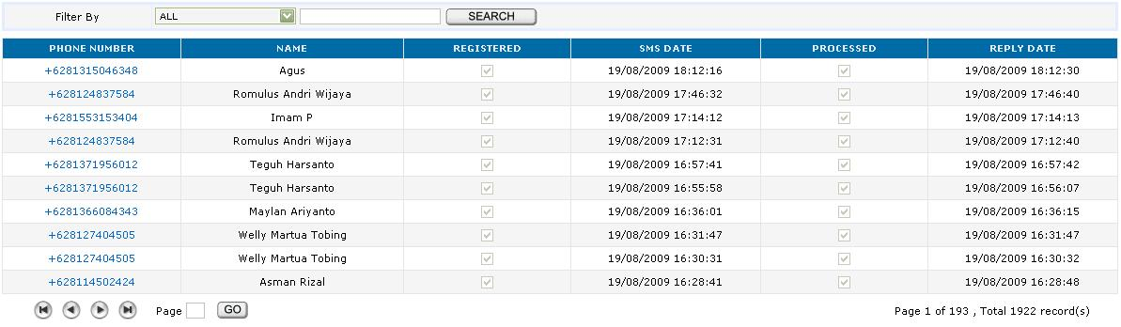

Hyperlink
Phone Number

Inbox View

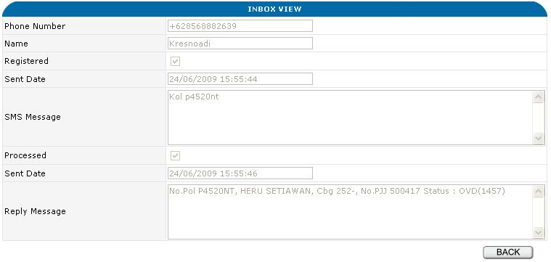

Button
Back

